Study the effect of vitamin C the processor magnetically in reduce toxicity of ochratoxin A on biochemical and histological parameters in rats

Wesam J. Al-jelehawy Ali H. D. Al-khafaji
Mohamd Rtha Al-Sharfee
Department of pathological analysis techniques/ College of humanities Studies university
Abstract :
The study showed of toxic effects of Ochratoxin A , In physiological and biochemical blood standards at four concentrations of ochratoxin A (50,100,150,200) µg/kg , where was concentration (200)µg/kg more toxicity which were represented by raised the number of white blood cells (6225.2) cells/mm³ compared with control group ((3231.1 cells/mm³.While the amount of hemoglobin decreased to ( 8.6 ) g/100ml , compared with control group (12.1) g/100ml and effect negatively on the enzyme GOT, GPT and the level of sugar in the blood, It reached its highest rate (43,49) IU/l , compared with control group (8.8 , 8.6) IU/l for both enzymes . While the level of sugar (131.1) mg/dl , compared with control group (87.5 ) mg/dl. Whereas the cholesterol level has decreased to (99.8) mg/dl , compared with control group (146.2) mg/dl .
While the results show the significant role of vitamin C at concentration of (500) mg/kg, especially magnetically processor at magnetic strength (1500) gauss to reduce the effects of physiological, biochemical and histological by ochratoxin A in experiment groups. Where the numbers of white blood cells represent(4581.1,4015.6) Cells/mm³ respectively, at treatment with vitamin C without untreated and vitamin C processor magnetically, compared with control group (3231.1) Cells/mm³.While the total amount of hemoglobin (9.8 , 10.5 ) g/100ml respectively in the two treatments, compared with control group (12.1) g/100ml . While the rate of GOT ( 29.7, 20.9 ) IU/L and GPT ( 28.1 , 19.6 ) IU/L respectively for both treatments, compared with the control group ( 8.8 , 8.6 )IU/L for both enzymes. Whereas the level of sugar ( 105.8 , 99.7 )mg/dl Respectively, compared with control group (87.5)mg/dl. While the cholesterol rate ( 109.8 , 119.1 ) mg/dl respectively, compared with control group (146.2) mg/dl .
Histological study showed that doses of ochratoxin A by four concentrations where caused histopathogenic changes in kidney highly proliferation of cell in endothelial layer in addition to hemorrhage . While in liver showed histopathogenic changes which represented of vascular congestion and necrosis . While the result showed by treatments with vitamin C processor magnetically and untreated the absence of histopathological changes at concentrations ( 50, 100 ) µg/kg from ochratoxin A . Whereas showed concentrations ( 150 , 200 ) µg/kg a few histopathological changes compared with previous groups.
Key words : Ochratoxin A , Vitamin C

Introduction
Ochratoxins belong to the group of mycotoxins that are produced as secondary metabolites by fungi, in particular Aspergillus and Penicillium. These fungi flourish under special conditions of temperature and humidity. Ochratoxins include ochratoxin A (OTA), ochratoxin B (OTB), ochratoxin C (OTC) and ochratoxin α (OTα), of which OTA is considered the most toxic. They are teratogenic, mutagenic, hepatotoxic, nephrotoxic and immunesuppressive, and thus pose a serious health problem for exposed humans and animals. Because the fungi infest several kinds of crops for OPEN ACCESS Toxins 2012, 4 245 human and animal consumption, the metabolites may be present in all kinds of raw agricultural materials, commodities and beverages. Due to their toxic properties regulations for mycotoxins, including ochratoxins, have been established, at this moment in 100 countries and readjusted in the course of time (6,27-29) .
Mycotoxins are challenging to classify, due to their diverse chemical structures and biosynthetic origins, their myriad of biological effects and their production by a wide number of different fungal species. Thus, mycotoxins can be classified as hepatotoxins, nephrotoxins, neurotoxins, immunotoxins, teratogens, mutagens, carcinogens, allergens, and so forth. Moreover, by their chemical structures, mycotoxins can be classified as lactones and coumarins, according to their biosynthetic origins, as polyketides, amino acid-derived, etc., and, finally, by the fungi that produce them (e.g., Aspergillus toxins, Penicillium toxins). Then, the same compound may get placed in different cognitive cubbyholes. Aflatoxin, for example, is a hepatotoxic, mutagenic, carcinogenic, difuran-containing, polyketide-derived Aspergillus toxin. Zearalenone is a Fusarium metabolite with potent estrogenic activity (7).
The ability of vitamin C to stimulate the immune response and protection against bacterial infection has now been established in fish (21). Vitamin C alleviate the aflatoxin effect on rabbits (25).
Material and methods :
The study was conducted at the College of Veterinary Medicine / University of Al-Qadisiya. Where used 42 from male rats of type Rattus norvegicus the ages of (12-14) Week.
Ochratoxin A: it was extracted from Aspergillus ochraceus on PDA media at according (14).
1-Preparation of ochratoxin A concentration :
ochratoxin A concentrations were (50,100,150,200)µg/kg ,where used dimethel sulfoxide (DMSO) as solvent to ochratoxin A.
2-Preparation of vitamin C :
The preparation of vitamin C in concentration of 500 mg by solvent water. Where to buy it from the pharmacy and the origin of Europe.
3-Animals: the experimental animals , male albino rats from type Rattus norvigicus , weighing 100-110 grams, were procured from the animal house of biology department, the animals divided to six groups . The dose of ochratoxin A and vitamin C of both types have been given per 48 hours and for 8 weeks after the end of experimental duration and after 2 days of test end , it had killed all the rats by drawing blood from stab the heart and the animals were conducted anatomical to extract liver and kidney for preparation of tissue sections .
The division of experimental animals to :
Group 1: includes 3 rats as control group .
Group 2: includes 3 rats given solvent of DMSO.
Group 3: includes 3 rats for dose 50 µg/ kg from ochratoxin A.
Group 4: includes 3 rats for dose 100 µg/ kg from ochratoxin A.
Group 5: includes 3 rats for dose 150 µg/ kg from ochratoxin A.
Group 6: includes 3 rats for dose 200 µg/ kg from ochratoxin A.
4-Physiological parameter :
According to the way (9).
5-Biochemical parameter :
According to the company's instructions (Roche Diagnostics ) .
6-Histopathological Study :
The preparation of tissue sections in Sadr Teaching Hospital in the department of histopathological in the province of Najaf. According to the way (5).
Result and discussion :
The results showed a significant effect of ochratoxin on physiological parameters. It was found through the results shown in the table (1) , that the rate of the number of white blood cells in the treatment of animals by four concentrations of ochratoxin A (50,100 ,150 ,200).Where it increased to (4011.1, 4625.4, 5632.7, 6225.2) cell/mm³ respectively, compared with the control group (3231.1) cell/mm³.

Table (1) Physiological and biochemical blood standard rate when the treatment of Ochratoxin
experimental groups | Physiological and biochemical blood standard rate when the treatment of Ochratoxin
 | WBC | HB | GOT | GPT | Sugar | Chole.
Control group | 3231.1 | 12.1 | 8.8 | 8.6 | 87.5 | 146.2
Treatment Group by DMS | 3232.4 | 12.6 | 8.9 | 8.8 | 88.2 | 148.5
Treatment by Och. at concentration 50 µg/kg | 4011.1 | 10.6 | 23.9 | 15.4 | 101.4 | 130.1
Treatment by Och. at concentration 100 µg/kg | 4625.4 | 9.9 | 50.1 | 27.8 | 110.6 | 101.8
Treatment by Och. at concentration 150 µg/kg | 5632.7 | 8.8 | 127 | 44 | 122 | 90.8
Treatment by Och. at concentration 200 µg/kg | 6225.2 | 8.6 | 143 | 49 | 131.1 | 81.4
LSD (0.05) | 9.84 | 0.73 | 3.91 | 0.82 | 0.76 | 0.78

This is agreement with the findings of the (19 ).The reason of increase in the number of white blood cells may be due to the ability of ochratoxin to induce excessive secretion of the immune response factors such as tumer necrosis factor (TNF) , interleukin-6 (IL-6) and cytokinases (16). The excessive production of these components are likely to be the reason for the increase in the number of white blood cells in experimental animals, or as a result of increased numbers of white blood cells acidophilus that remove toxic substances from the body(23).
While the amount of hemoglobin it has been decrease, where were the rate (10.6, 9.9 , 8.8, 8.6) g/100 ml. At the treatment of ochratoxin by four concentrations ,compared with the control group (12.1) g/100 ml.
The cause of low hemoglobin rate may come back to increase the production of excessive immune response factors, including cytokinases in experimental animals, it influenced on increase in oxidative process in the cell due to the increase of free radicals that attack the red blood cells, causing the degradation and thus lack the amount of hemoglobin (12).
The increase of the dose in the experimental animals important to maximize the impact of ochratoxin on physiological blood standard rate , where it observed the gradual rise in the number of white blood cells rate with increasing dose. As their numbers rose from (4011.1) cell/mm³ , at the first dose (50 µg/kg) to (6225.2) cell/mm³ , at the last dose compared with control group (3231.1) cell/mm³ . Also the increase in dose of ochratoxin A , it influenced on decrease of hemoglobin. Where was (10.6) g/100 ml, at the first dose (50 µg/kg), and the last dose (8.6) g/100 ml compared with control group (12.1) g/100 ml .These results agreed with what reached (22). Where he noted that giving low doses of ochratoxin to experimental animals has been no change in the physiological blood standards but increase the dose is increased impact on the numbers of white blood cells and the rate of biochemical parameters.(10)
Biochemical parameters :
Enzymes are biochemical molecules controls the metabolic processes within the body and that any increase or decrease in the rate of enzymes gives an idea about a defect in the organ that resides where these enzymes.(4)
The results of this study are described in the table (1) showed the negative impact of ochratoxin A on the enzymes (GOT and GPT) , at four concentrations (50,100,150,200) µg/kg of ochratoxin A . It led to raise the rate of enzymes GOT to (23.9,50.1,127,143) IU/L respectively, compared with control group (8.8) IU/L. While the rate of enzyme GPT (15.4, 27.8, 44, 49) IU/L respectively, compared with control group (8.6) IU/L.
The cause of rise these two enzymes in the blood of experimental animals serum, it came from the effect of ochratoxin A on liver cells which containing on these enzymes which led to the liberation of these enzymes and then rise in their levels in the blood or affected other organs such as the kidney and membranes of endoplasmic reticulum , where these enzymes or cause an imbalance in the vital transportation system in the body.(20)
While the level of glucose in the blood serum of experimental animals at four concentrations , it led to increased sugar level to (101.4,110.6,122,131.1) mg/dl respectively, compared with control group(87.5) mg/dl, table (1).
The reason for the high of sugar level by effect of ochratoxin is interfering with the metabolism of glucose and the effect of the enzymes responsible for regulating the amount of sugar in the blood, such as insulin. This is referred by the World Health Organization (30). While was the impact of ochratoxin negatively on cholesterol level , where were the levels (130.1,101.8,90.8,81.4 ) mg/dl respectively , compared with control group (146.2) mg/dl, table (1). The secondary metabolic products have higher familiarity to membranes of mitochondria causing a rapid degradation. As well as the inhibition of protein transport chain (26). This inhibition may lead to a decline in the production of the necessary energy for the synthesis of cholesterol. This study agreed with the findings of (3).
While the results show the significant role of vitamin C, especially processor magnetically to reduce the effects on the physiological and biochemical parameters in animals treated with ochratoxin A, table (2) .Vitamin C increases white blood cell production and is important to immune system balance(13).

Table (2) Physiological and biochemical blood standard rate when the treatment of Ochratoxin and vitamin C.
experimental groups | Physiological and biochemical blood standard rate when the treatment of Ochratoxin and vitamin C
 | WBC | HB | GOT | GPT | Sugar | Chole.
Control group | 3231.1 | 12.1 | 8.8 | 8.6 | 87.5 | 146.2
Treatment Group by DMS | 3232.4 | 12.6 | 8.9 | 8.8 | 88.2 | 148.5
Treatment by Och. at concentration 50 µg/kg and vitamin C | 3360.2 | 12 | 10.6 | 9.6 | 89.1 | 141.8
Treatment by Och. at concentration 100 µg/kg and vitamin C | 3821.1 | 11.3 | 35.8 | 13.2 | 92.3 | 135.9
Treatment by Och. at concentration 150 µg/kg and vitamin C | 4210.3 | 10.7 | 68.2 | 24.8 | 101.4 | 118.6
Treatment by Och. at concentration 200 µg/kg and vitamin C | 4581.1 | 9.8 | 78.8 | 29.1 | 110.1 | 98.3
LSD (0.05) | 7.22 | 0.59 | 2.55 | 0.58 | 0.56 | 0.66

The results showed of the use of vitamin C significant differences (P<0.05) were apparent at four concentrations of ochratoxin A in experimental animals, where improved of metabolic process , comparing with other groups and insignificant level with control. These results of vitamin C agree with those obtained by (25) on rabbits. These results of vitamin C may be due to increasing feed intake, digestibility of nutrients which had biological role in digestive enzyme biosynthesis and activation (1). Also vitamin C improve the immunity of rats by enhance the phagocytic ratio and serum lysozyme activity (24). Also increased of respiratory process , activity of blood neutrophils and antibody levels (21).
Magnetized water which containing vitamin C activate the body's immunity and increase the activity of the kidneys to get rid of toxins in the urine with high efficiency(11).

Table (2) Physiological and biochemical blood standard rate when the treatment of Ochratoxin and magnetic vitamin C .

experimental groups | Physiological and biochemical blood standard rate when the treatment of Ochratoxin and magnetic vitamin C
 | WBC | HB | GOT | GPT | Sugar | Chole.
Control group | 3231.1 | 12.1 | 8.8 | 8.6 | 87.5 | 146.2
Treatment Group by DMS | 3232.4 | 12.6 | 8.4 | 8.8 | 88.2 | 148.5
Treatment by Och. at concentration 50 µg/kg and vitamin C | 3360.2 | 12 | 10.4 | 9.6 | 89.1 | 141.8
Treatment by Och. at concentration 100 µg/kg and vitamin C | 3821.1 | 11.3 | 34.1 | 13.2 | 92.3 | 135.9
Treatment by Och. at concentration 150 µg/kg and vitamin C | 4210.3 | 10.7 | 67.4 | 24.8 | 101.4 | 118.6
Treatment by Och. at concentration 200 µg/kg and vitamin C | 4581.1 | 9.8 | 77.9 | 29.1 | 110.1 | 98.3
LSD (0.05) | 6.99 | 0.64 | 1.90 | 0.61 | 0.52 | 0.55

Histopathological examinations :
The results of the microscopic diagnosis of histological sections of the liver and kidneys of rats that have been treated ochratoxin A. The sections showed the presence of changes in each of the tissue below. It has appeared in the liver of the presence of severe vascular congestion and focal gathering of inflammatory cells , figure (1) .
The reason for this is that by effects of ochratoxin A , it has an effect on the plasma membrane lipids. As it leads to loss of membrane integrity then cell lysis and the occurrence of necrosis .( 22).
The cause of vascular congestion in the liver, may be due to the impact of mycotoxins on the plasma membrane and lead to the loss of elective permeability property to the membrane. This accounts for why the water out from the cells within the liver and degeneration.(12) .This is agreement with (15,2).
The results showed in tissue sections of kidney in found of contraction in the glomerulus , hyperplasia in the wall of the glomerulus and bleeding in treatment animals by ochratoxin A, figure (2) . Besides having congestion in the renal tubule and the presence of the beginning of the occurrence of acute renal glomeruli (18) .
This Odema may be caused by a disturbance in the distribution of body fluids so accumulate additional quantities of them in cells or inside the cells or due to lack of or imbalance in the distribution of proteins in the body.(23)
While the results show the significant role of vitamin C, figure (3,4) especially processor magnetically in animals treated with ochratoxin A. Especially at the concentrations (50,100) µg/kg , showed no histopathological changes. While at concentrations (150,200) µg/kg , showed low histopathological changes compared with treatment groups by ochratoxin A at the same concentrations without vitamin C, figure (5,6) . Previous results have shown that vitamin C reduces 90% of the effect of ochratoxin A. They added that vitamin C is an important antioxidant and a free radical scavenger, thereby preventing the production of electrophilic metabolites(8).
Magnetized water that contain vitamin C working to reduce the surface tension and the ability to become a high solvent of vitamin C and thus influence the rapid and easy absorption and therefore better achievement of vitamin function and the resistant to mycotoxins(17).

Figure (1) Sections in the liver tissues of the white rat. (A) Control group. (B) The treatment of ochratoxin at concentration 50 µg/kg . (C) The treatment of ochratoxin at concentration 100 µg/kg. (D)The treatment of ochratoxin at concentration 150 µg/kg. (E) The treatment of ochratoxin at concentration 200 µg/kg .(1-necrosis 2- focal gathering of inflammatory cells 3-bleeding )
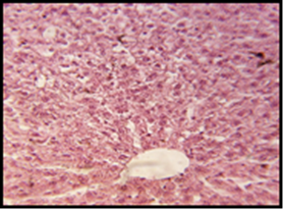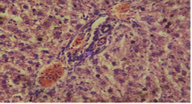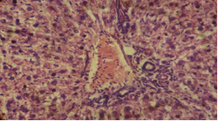
3
2
1
C
A
B
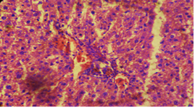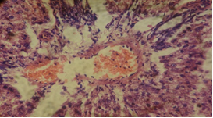
E
D

Figure (2 ) Sections in the kidney tissues of the white rat. (A) Control group. (B) The treatment of ochratoxin at concentration 50 µg/kg . (C) The treatment of ochratoxin at concentration 100 µg/kg. (D)The treatment of ochratoxin at concentration 150 µg/kg. (E) The treatment of ochratoxin at concentration 200 µg/kg .(1- hyperplasia in the wall of the glomerulus 2-bleeding )
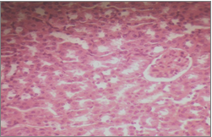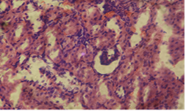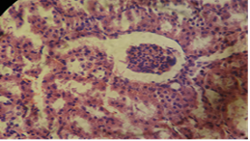
C
B
A
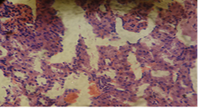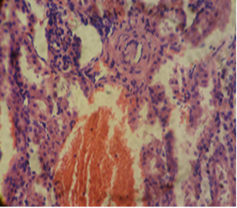
E
D
Figure (3 )Sections in the liver tissues of the white rat. (A) Control group. (B) The treatment of ochratoxin at concentration 50 µg/kg . (C) The treatment of ochratoxin at concentration 100 µg/kg. (D)The treatment of ochratoxin at concentration 150 µg/kg. (E) The treatment of ochratoxin at concentration 200 µg/kg . (1-necrosis 2- focal gathering of inflammatory cells 3-bleeding ).
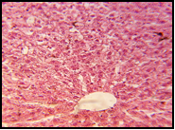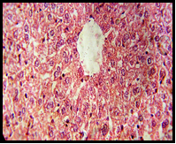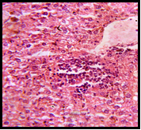
B
C
A
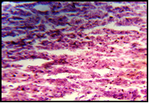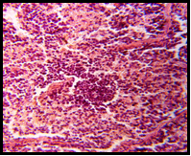
E
D
Figure (4 ) Sections in the kidney tissues of the white rat. (A) Control group. (B) The treatment of ochratoxin at concentration 50 µg/kg . (C) The treatment of ochratoxin at concentration 100 µg/kg. (D)The treatment of ochratoxin at concentration 150 µg/kg. (E) The treatment of ochratoxin at concentration 200 µg/kg .(1- hyperplasia in the wall of the glomerulus 2-bleeding).
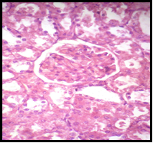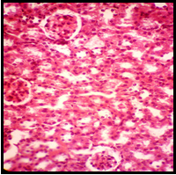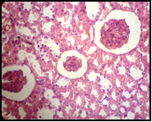
B
C
A
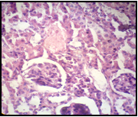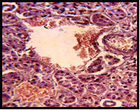
E
D
Figure (5 ) Sections in the liver tissues of the white rat. (A) Control group. (B) The treatment of ochratoxin at concentration 50 µg/kg . (C) The treatment of ochratoxin at concentration 100 µg/kg. (D)The treatment of ochratoxin at concentration 150 µg/kg. (E) The treatment of ochratoxin at concentration 200 µg/kg . .(1-necrosis 2- focal gathering of inflammatory cells 3-bleeding ).
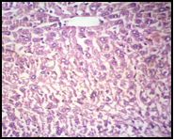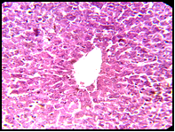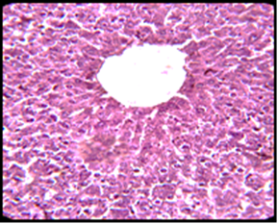
C
B
A
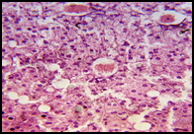
E
D
Figure (6 ). Section in the kidney tissue of the white rat. (A) Control group. (B) The treatment of ochratoxin at concentration 50 µg/kg . (C) The treatment of ochratoxin at concentration 100 µg/kg. (D)The treatment of ochratoxin at concentration 150 µg/kg. (E) The treatment of ochratoxin at concentration 200 µg/kg .(1- hyperplasia in the wall of the glomerulus 2-bleeding).
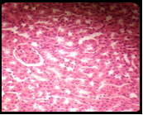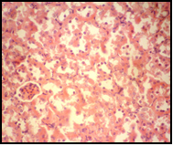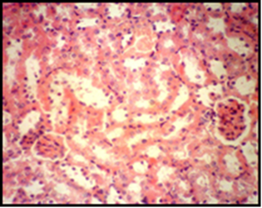
C
B
A
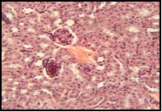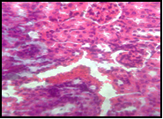
D
E

References :
- Abd El-Mageed, F.A. (1987). Some biological and nutritional studies on aflatoxins. MSc. Thesis, Zagazig Univ., Fac. of Agric.
- Al-Anati, L. and Petzinger, E. (2006). Immunotoxic activity of ochratoxin A. J. Vet. Pharmacol. Therap., 29: 79–90.
- Anyanwu ,E.C.; Ehiri,J.E. and Kanu ,I.(2007).High cholesterol level and chronic exposure damp buildings. The international Journal of Toxicology,41:159-316.
- Arneson,W. and Brickell ,J.(2007).Assessement of liver function .In:Clinacal chemistry,Alaboratory perspective .F.A.Davis .Co.Philadelphia ,pp :233-266.
- Bancroft, J. D. and Stevens A. (1982) . Theory and practice of Histology techniques . Churchill Living Stone, New York. 117 .
- Bazin, I.; Nabais, E.; Lopez-Ferber, M.(2010). Rapid visual tests: Fast and reliable detection of ochratoxin A. Toxins. 2, 2230–2241.
- Binder, E.M.(2007). Managing the risk of mycotoxins in modern feed production. Anim. Feed Sci. Technol. 2007, 133, 149–166.
- Bose, S. and Sinha, S. P. (1994). Modulation of ochratoxin-produced genotoxicity in mice by vitamin C. Food. Chem. Toxicol., 32 (6): 533 -537.
- Brown,B.A.(1976).Principles and procedure.2nd ed.,Lea and Febiger .Philadelphia.New York.pp,78.
- Clohrty,E.K.;Livine,K.B.and Carruthers,A.(2001).The red blood cell glucose transporter presents multiple ,nucleotide sensitive sugar exit sites.Biochemestry,40 :15549-15561.
- Coals Klassen, V.I. (1990).Magnetic Treatment of Water and Aqueous Systems in Flotation and Thickening of Ores and Proceedings VIII International Mineral Processing .
- Guton, A.C. and Hall, J.F.(1997).Textbook of medical physiology. 5th.ed. Saunders . Co.London,pp:503-549.
- Haazele, F. M., W. Guenter, R. R. Marquardt, and A. A. Frohlich, 1993. Beneficial effects of dietary ascorbic acid supplement on hens subjected to ochratoxin A toxicosis under normal and high ambient temperatures. Can. J. Anim. Sci. 73:149-157.
- Jones, B.D. (1972). Methods of Aflatoxin analysis . Tropical Products Institute Rep., ( G70 ) .
- Kemacki, A.; Mary,Y. and Dery, H., (1997). Physiology and Histopathology .New York.pp:50-60.
- Kemacki, A.; David, M. and Broti, M. (1998). Histopathology ,O.Chuchil Living stone .New York.pp:12-14.
- Kenneth, W.; Busch, et. al.,(1995).Magnetic Water Treatment Devices, The Results of a University Study Busch, Proceedings International Water Conference.
- Luty, S.; Przebirowska, D.O.; Latuszynska, J. and Rodak, M.T. (2001). Histological and ultra structural studies of rats exposed to mycotoxins .Ann.Agric. Environ.Med.9:12-34.
- Marin, D. E.; Taranu, I. R. P.;Bunacin, F.; Pascale, Tudor, D. S.; Avram, N.; Sarca, M.; Cureu, I.; Criste, R. D.; Stuta, V. and Oswald, I. P. (2002). Changes in performance, blood parameters , humoral and cellular immune responses in weanling piglets exposed to low doses of aflatoxin. J. Anim. Sci., 80: 1250-1257.
- Meerdink, G. L. (2004). Aflatoxins . In: Plumlee, K. H. (ed.). Clinical veterinary toxicology . Little Rock, Arkansas, USA.pp:231-235.
- Nayek S.K.; P. Swain and S.C. Mukherjee (2007). Effect of dietary supplementation of probiotic and vitamin C on the immune response of indian major carp, Labeo rohita (Ham.). Fish & Shellfish Immunol., 23 (4): 892-896.
- Papiya, M.(2005). Pharmacological and toxicological studies of some mycotoxins in animals.J.Med.Vol.44,No.78.
- Peraica, M.; Radic, B.; Lucic, A. and Pavlovic, M. (1999). Toxic effect of mycotoxius in humans. Bulletin of The World Health Organization.
- Sahoo P.K. and S.C. Mukherjee (2003). Immunomodulation by dietary vitamin C in healthy and aflatoxin B1-induced immunocompromised rohu (Labeo rohita). Comparative Immunology, Microbiology and Infectious Diseases, 26 (1): 65-76.
- Salem, M.H.; K.I. Kamel; M.I. Yousef; G.A. Hassan and F.D. El-Nouty (2001). Protective role of ascorbic acid to enhance semen quality of rabbits treated with sublethal doses of aflatoxin B1. Toxicology, 21, 162 (3): 209- 218.
- Stoytocho,S.; Geno, A. and Dimitar, P.L.P.(1999).Some antidotes and paraclinical investigation in expermintal intoxication with ochratoxin A and penicillic acid in chicks .Veterinarski .Archiv.,69(4):179-189.
- Van Egmond, H.P.(1991). Methods for determing ochratoxin A and other nephrotoxic mycotoxins. IARC Sci. Publ. 115, 57–70.
- Van Egmond, H.P.(1996). Analytical methodology and regulations for ochratoxin A. Food Addit. Contam. 13 (Suppl.), 11–13.
- Van Egmond, H.P.; Schothorst R.C.; Jonker M.A..(2007). Regulations relating to mycotoxins in food. perspectives in a global and European context. Anal. Bioanal. Chem. 389, 147–157.
- WHO,(2002).Laboratory diagnisis and monitoring of diabetes mellitus.

